1. Create the vectors

(a) (2, 3, ... , 29, 30)

(b) (30, 29, ... , 2)

(c) (1, 2, 3, .... , 29, 30, 29, 28, , 2, 1)

(d) (4, 6, 3) and assign it to the name dev.

For parts (e), (f) and (g) .

(e) (5, 6, 7, 5, 6, 7, , 5, 6, 7) where there are 10 occurrences of 5.

(f) (5, 6, 7, 5,

6, 7, , 5, 6, 7, 5) where there are 11 occurrences of 5, 10 occurrences of 6 and 10

Occurrences of 7.

(g) (4, 4, , 4, 6, 6, , 6, 3, 3, , 3) where there are 10 occurrences of 4, 20 occurrences of 6 and 30

Occurrences of 3.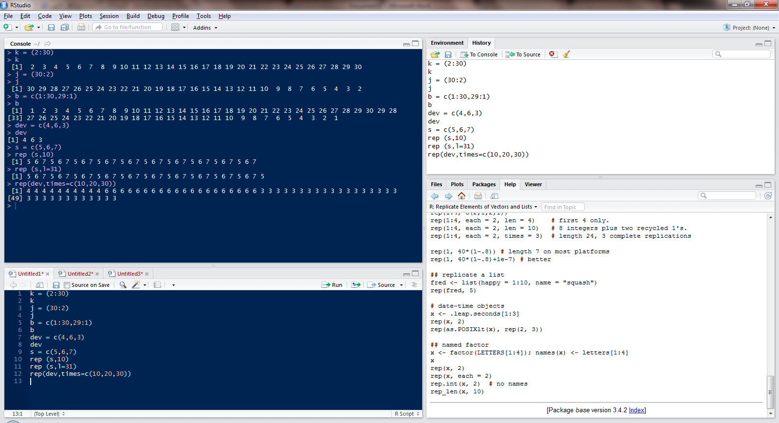

2. Create a vector of the values of eX sin(x) at x = 3, 3.1, 3.2, , 6.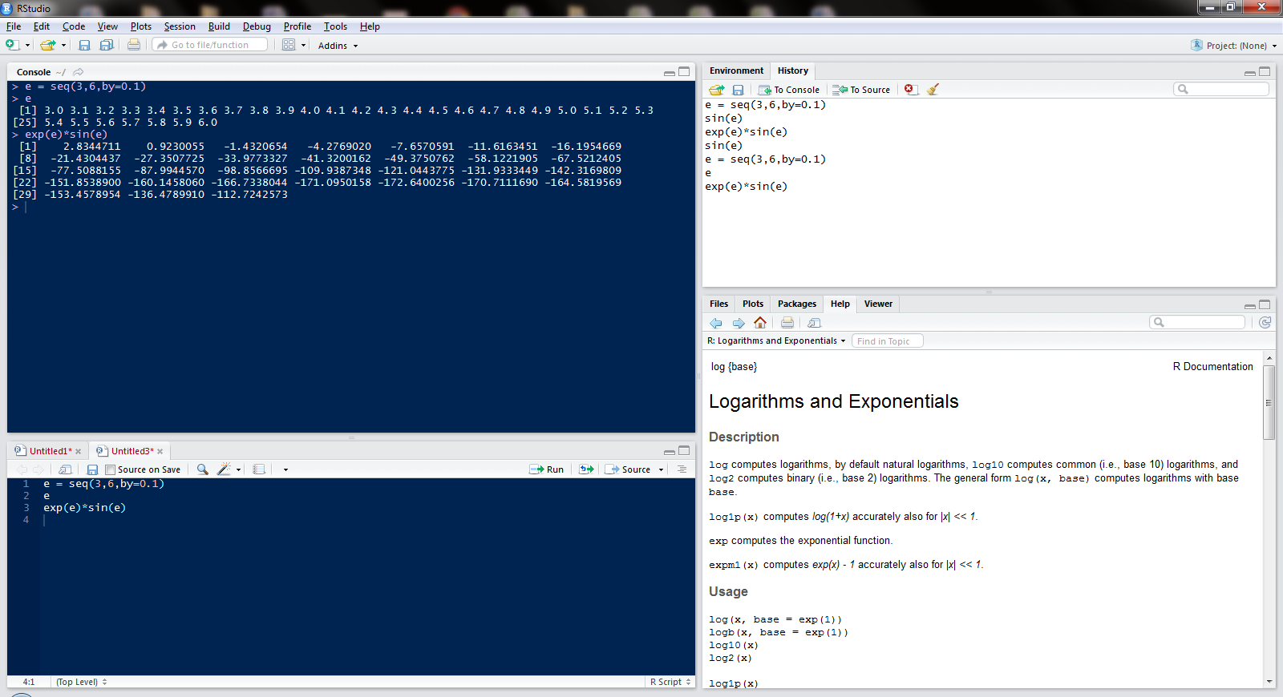

Execute the following lines which create two vectors of random integers which are chosen with

replacement from the integers 0, 1, : : : , 999. Both vectors have length 250.

set.seed(100)

x <- Sample (0:999, 250, replace=T)

y <- Sample (0:999, 250, replace=T)

(a) Identify out the values in y which are > 500.

(b) Identify the index positions in y of the values which are > 700?

(c) What are the values in x which are in Same index position to the values in y which are > 400?

(d) How many values in y are within 200 of the maximum value of the terms in y?

(e) How many numbers in x are divisible by 2?

(f) Sort the numbers in the vector x in the order of increasing values in y.

(g) Create the vector (x1 + 2x2 - x3; x2 + 2x3 -x4 ,, xn−2 + 2xn−1 - xn).

(h) Calculate:

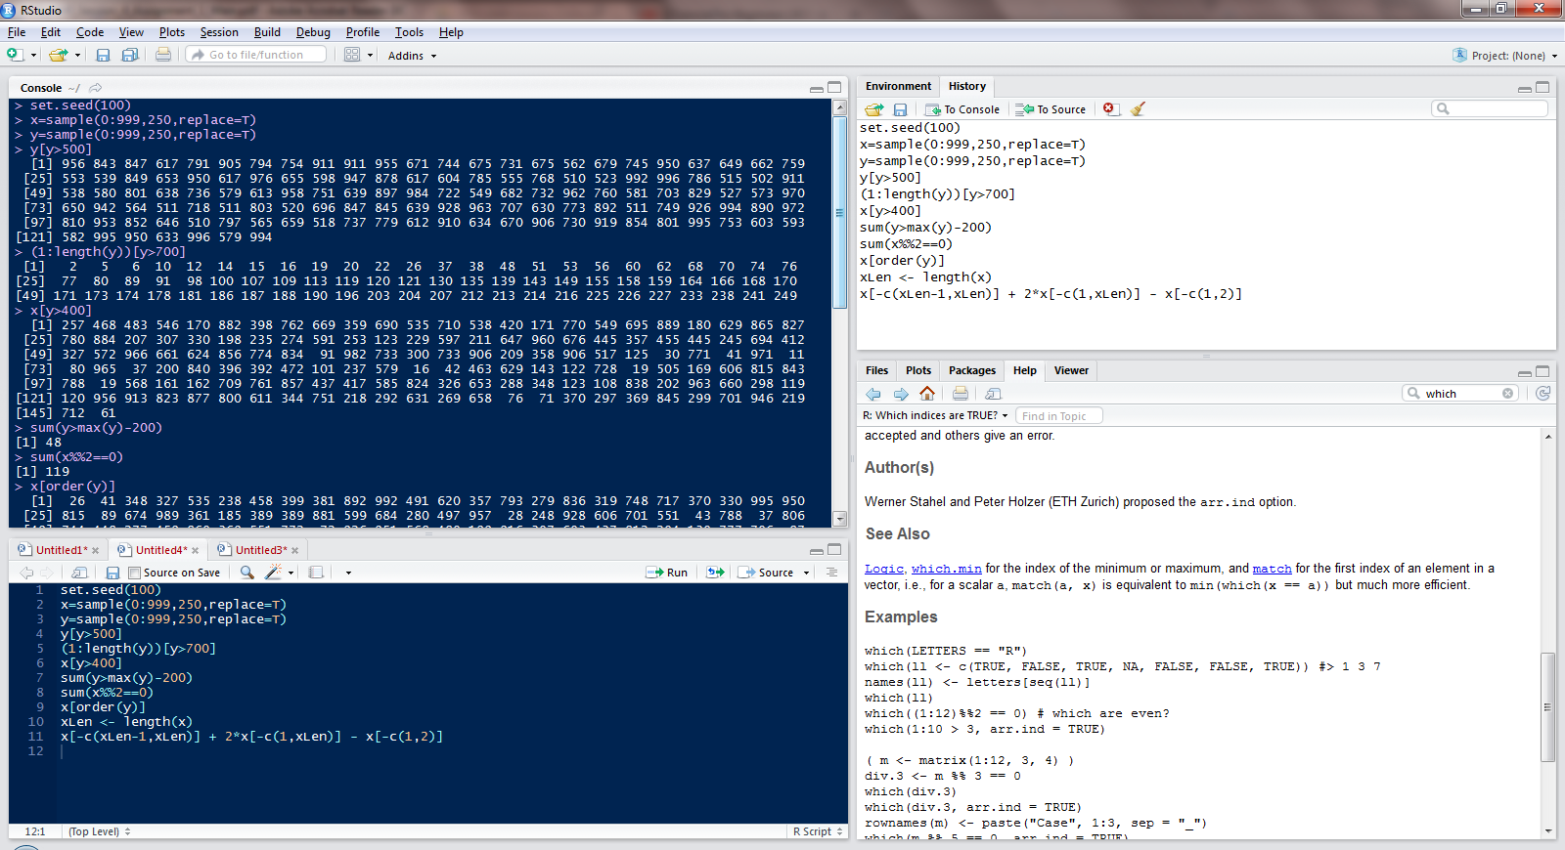

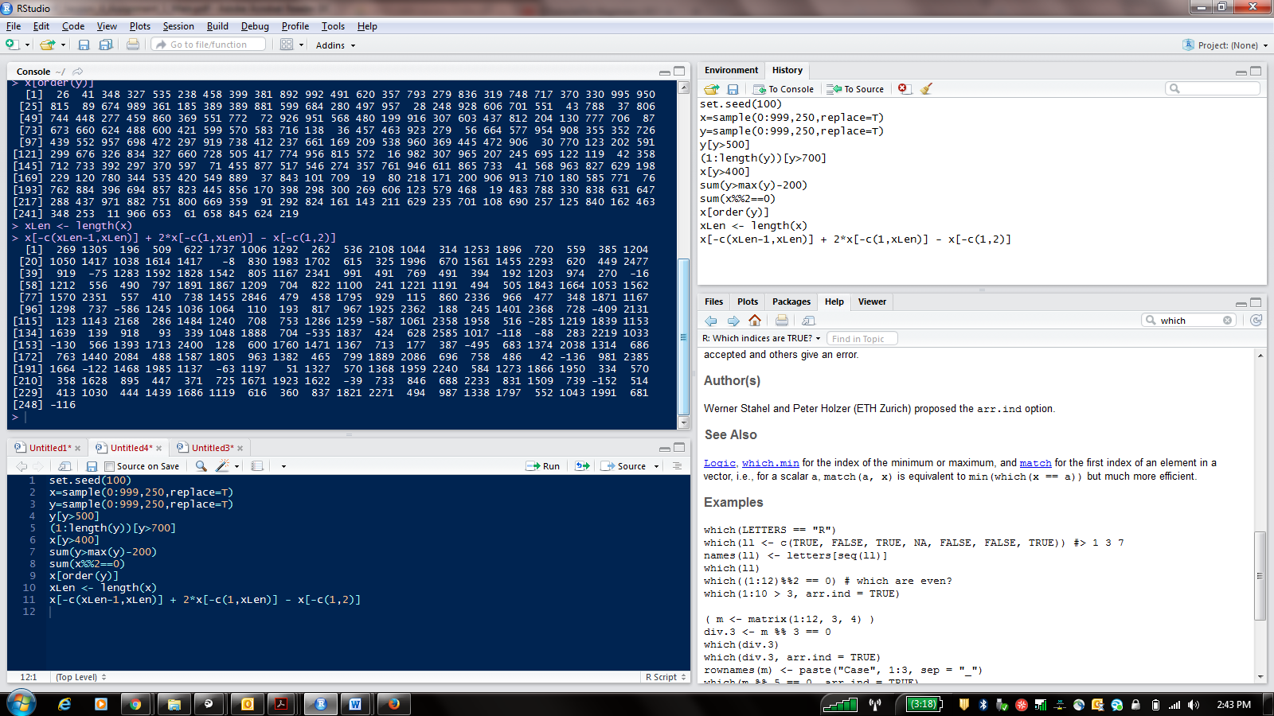

4. Use the function paste to create the following character vectors of length 30:

(a) ("Label 1", "Label 2", ....., "Label 30").

Business Analytics with R

ACADGILD

Page 4

\*Note that there is a single space between label and the number following.

(b) ("FN1", "FN2", ..., "FN30").

\*\*In this case, there is no space between fn and the number following.

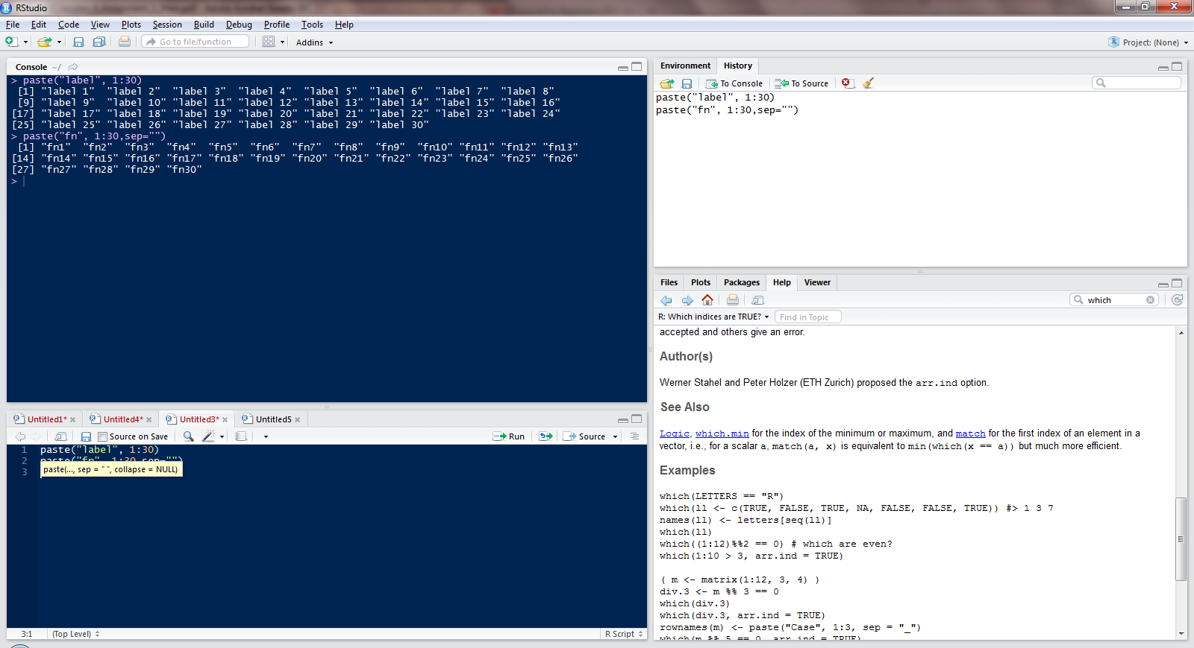

5. Compound interest can be computed using the formula

A = P × (1 + R/100)n, where P is the original money lent, A is what it amounts to in n years at R percent per year interest.

Write R code to calculate the amount of money owed after n years, where n changes from 1 to 15 in yearly increments, if the money lent originally is 10000 Rupees and the interest rate remains constant throughout the period at 11.5%.

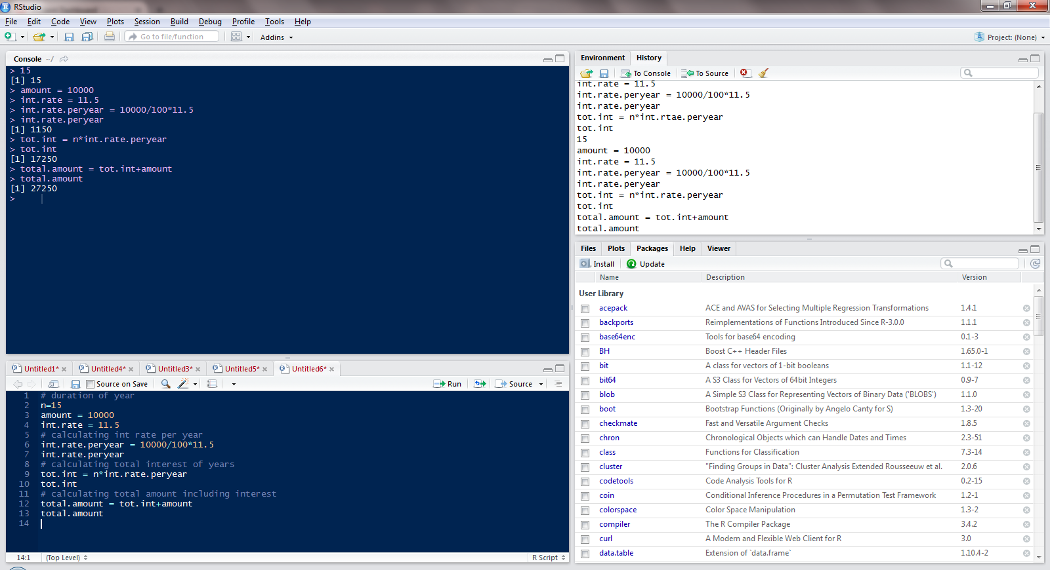

6) Generate the following matrices.

[,1] [,2] [,3] [,4]

[1,] 1 101 201 301

[2,] 2 102 202 302

[3,] 3 103 203 303

[4,] 4 104 204 304

[5,] 5 105 205 305

